Week 4
Q1. Write a C++ program to check whether a number is even or odd using ternary operator.
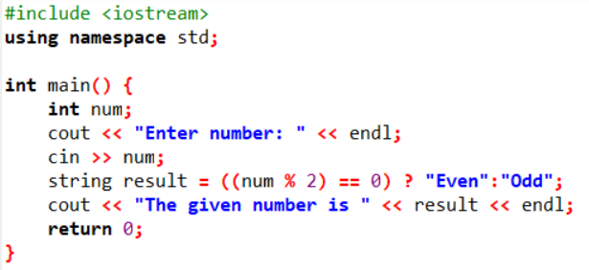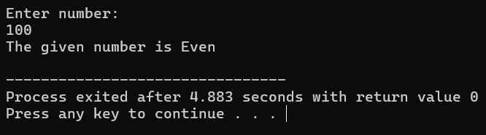
Q2. Write a C++ program to perform the addition of two numbers without using + operator.
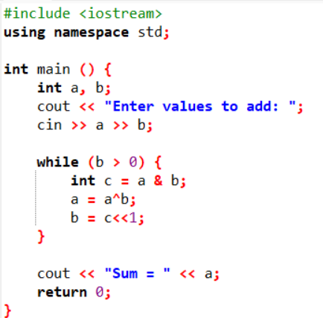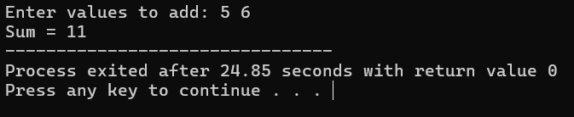
Q3. Write a C++ program to evaluate the arithmetic expression ((a + b / c * d- e) * (f- g)). Read the values a, b, c, d, e, f, g from the standard input device.
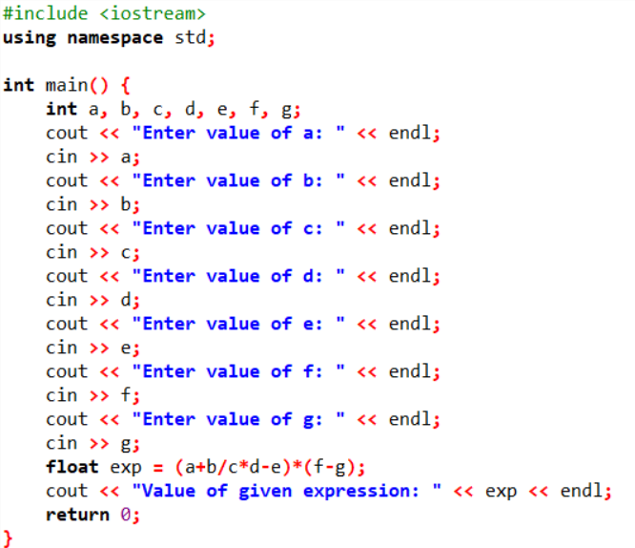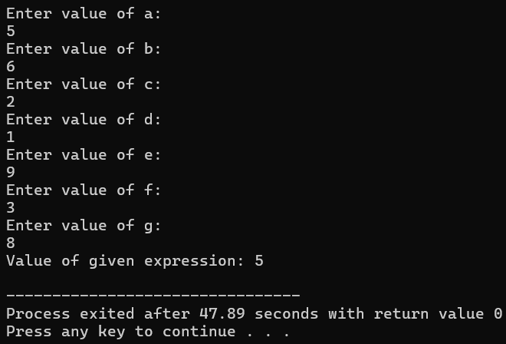
Q4. A Fibonacci sequence is defined as follows: The first and second terms in the sequence are 0 and 1. Subsequent terms are found by adding the preceding two terms in the sequence. Write a C++ program to generate the first n terms of the sequence.
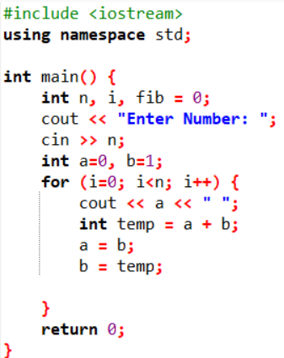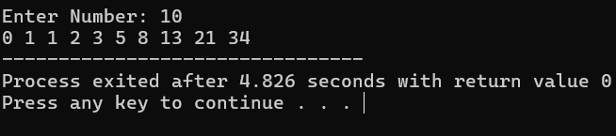
Q5. Write a C++ program to generate all the prime numbers between 1 and n, where n is a value supplied by the user.
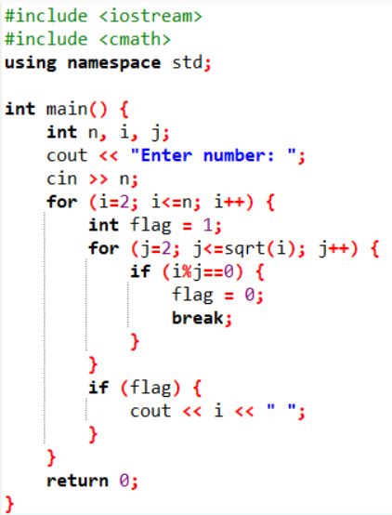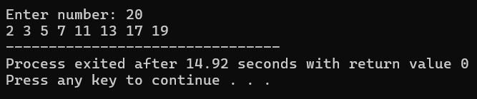
Q6. A character is entered through keyboard. Write a C++ program to determine whether the character entered is a capital letter, a small case letter, a digit or a special symbol using if-else and switch case. The following table shows the range of ASCII values for various characters. Characters ASCII values A– Z: 65– 90, a– z: 97– 122, 0– 9: 48– 57 Special symbols 0– 47, 58– 64, 91– 96, 123– 127
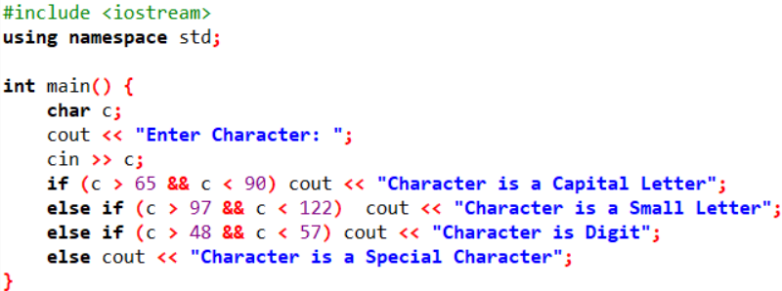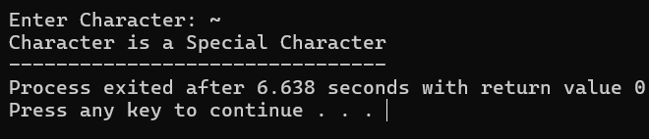
Q7. Write a C++ program to find the roots of a quadratic equation.
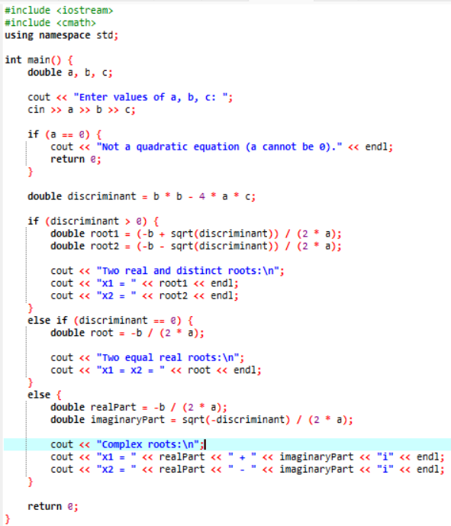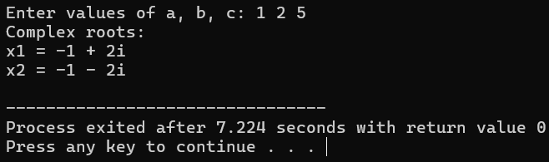
Q8. Write a C++ program to check whether a given 3-digit number is an Armstrong number.
